1.52: For all of these pairs of vectors, the angle is found from combining Equations (1.18) and (1.21), to give the angle as

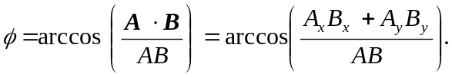

In the intermediate calculations given here, the significant figures in the dot products and in the magnitudes of the vectors are suppressed.

a) 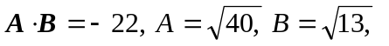and so

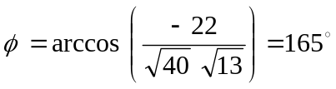.

b) 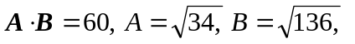 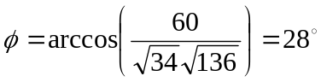.

c) 